Project 1 - Expense Reimbursement System

Entity Relationship Diagram and Application Programming Interface Design

Keith Salzman

ERD Diagram

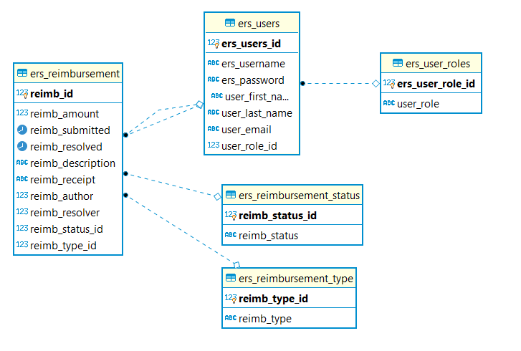

API Design (Basic Project Goals)

* Employee - Interacts with all five data entities within ERD by GET or POST
  + GET /employee/:id/reimbursement - retrievers all reimbursement requests tickets submitted by single employee according to their ID.
  + POST /employee/reimbursement - Adds a new reimbursement request to the database
  + POST /employee/login/ - compares, through data sent in POST request body, hash of user entered password to hash of password stored in database associated with a given entered username, if matching allows access to web app tools based upon corresponding user role (employee or finance manager)
* Finance Manager - Interacts with all five data entities within ERD by GET or PATCH
  + GET /financemanager/reimbursement - retrieves all reimbursement requests submitted by all employees regardless of status or ID.
  + GET /financemanager/reimbursement/:status - retrieves all reimbursement requests that possess one of the three specific statuses possible in the system: approcced, denied or pending.
  + PATCH /financemanager/reimbursement/status - updates the reimbursement status of a reimbursement request previously submitted.